|  |  |
| --- | --- |
| Assignment 4  ITRI 626 | ENRICO DREYER  31210783 |

Table of Contents

Introduction 2

How does neural networks work? 2

What is Neural network training? 3

How is training applied? 3

Conclusion 3

References 4

# Introduction

For this assignment we were asked to write a report on neural network training. Below is a simplified schema of a neural network architecture. I kept this in the back of my mind while writing this report and doing the practical so that it makes more sense.

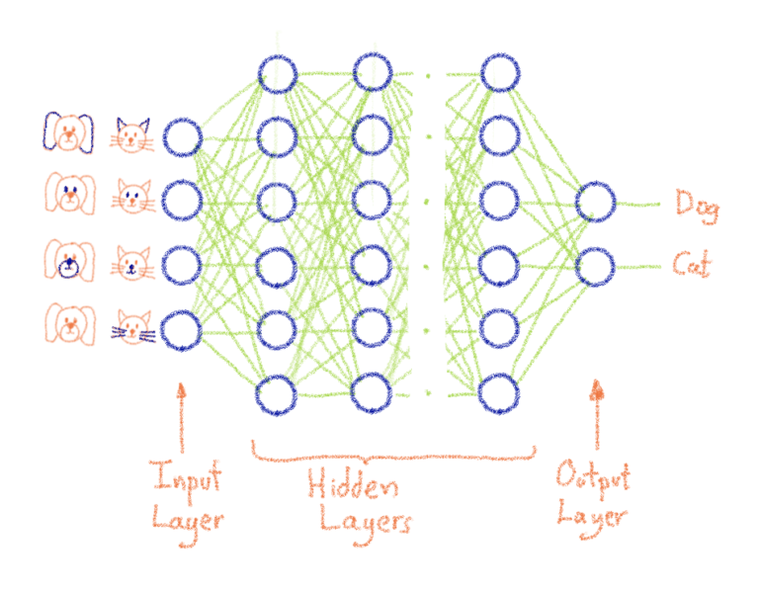

Figure : Neural network architecture (Queguiner, 2020)

# How does neural networks work?

When you think of each node as having its own linear regression model that consists of input data, weights, thresholds, and outputs you can construct a formula that looks similar to the ones below:Text, logo

Figure 2: Neural Network Linear Regression Formula 1 (Education, 2020)

Figure 3: Neural Network Linear Regression Formula 2 (Education, 2020)

As input layers are determined they are assigned weights, larger weights contribute significantly more to the output compared to the smaller weights. The inputs are multiplied by the weights that they are assigned to, then counted together. After that the output is formulated using an activation function, determining its output.

As an output exceeds a given threshold, the node is passed to the next layer of the network (Education, 2020). In the assignment this was determined by the “relu(x)”, if my understandings are correct. The result of the output is then passed on to the next node as input. The whole process of passing outputs to the next nodes defines the neural network as being a feedback network.

Most of the deep learning neural networks are feedforward, this means that they only flow in one direction (input to output). There is also a way of training a neural network with the use of backpropagation, meaning it can flow in the opposite direction (output to input). This allows the calculation and attribution of the error that is associated with each neuron (Education, 2020). Backpropagation allows the adjustment and fitment of parameters of models appropriately.

# What is Neural network training?

To train a neural network means that all neurons of a given layer generates a given output, although they do not have the same weight for the follow up neurons layer. With that said, if a Neuron on a given layer observes a pattern, it can mean less of the overall picture and will be completely or primarily muted (Queguiner, 2020). A bigger weight means that an input is more important, and a smaller weight means that the input has a smaller impact on the output. Between each neural connection there is a neuron with an associated weight, this is called weighting (Queguiner, 2020).

Referring to Figure 1, the “magic” of neural networking adaptability is that the weights are adjusted while the training takes place, this is to fit the objectives that are set. The goal of the network is to recognize that the “dog” is a “dog” and the “cat” is a “cat”.

In the simplest terms training a neural network is finding the correct weights of the Neural connections, with the use of a feedback loop called Gradient Backwards propagation (Queguiner, 2020).

# How is training applied?

When starting off with training a neural network, the initial weights are chosen at random. In the assignment it is chosen by the “weight_0_1 = 2 * np.random.random((3,hidden_size)) - 1” method. This indeed will not give us good results. The goal is to start of with a bad performing neural network and end up with a neural network with a high accuracy (Bushaev, 2017). When thinking of training a neural network, it is equivalent to minimizing the loss function (Bushaev, 2017).

Any problem that can be solved through the use of a neural network can be expressed in a mathematical way. For the example in Figure 1, a function can be found to take all the numbers from the images and output a probability that it is either a dog or a cat. The idea of training is that as long as there is a dataset with inputs and labels, there is going to be a function that works exceptionally well with the given dataset.

# Conclusion

The more understanding there is of neural network and training the more it can be applied to various fields. The simple example of giving a neural network a dataset of images containing dogs and cats, proved useful in understanding what neural network training is. For this assignment we had to write a report on neural network training, and in simple terms training a neural network is to start of with a network with bad accuracy, then end up with a network with high accuracy.

# References

Bushaev, V. (2017). How do we ‘train’ neural networks ? <https://towardsdatascience.com/how-do-we-train-neural-networks-edd985562b73>

Education, I. C. (2020). Neural Networks. <https://www.ibm.com/cloud/learn/neural-networks>

Queguiner, J.-L. (2020). What does Training Neural Networks mean? <https://blog.ovhcloud.com/what-does-training-neural-networks-mean/#:~:text=In%20simple%20terms%3A%20Training%20a%20Neural%20Network%20means,Parallel%20between%20Control%20Theory%20and%20Deep%20Learning%20Training>